2026 SPONSORSHIP PACKET

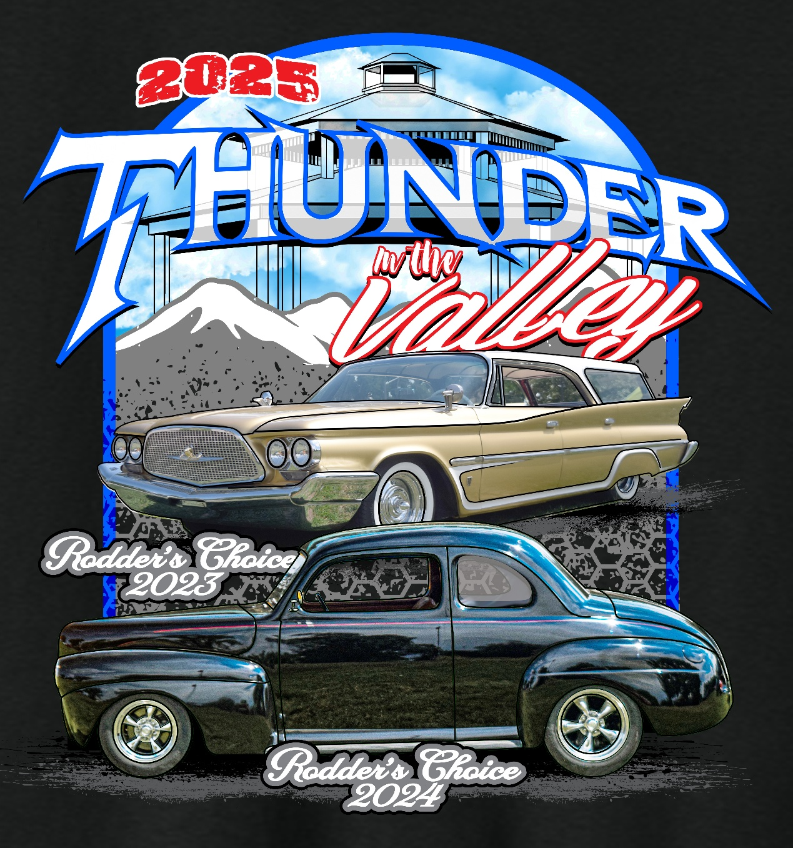

Thunder in the Valley Cruise and Car Show
P.O. Box 31532
Colorado Springs, CO 80931

Poker Run Date: July 10th, 2026
Car Show Date: July 11th, 2026



Thunder in the Valley Cruise and Car Show
P.O. Box 31532
Colorado Springs, Colorado 80931

Dear Potential Sponsor,

Thunder in the Valley would like to invite you to contribute your sponsorship via
funds, merchandise, door prizes, gift certificates/gift cards or any other in-kind gifts. Your
sponsorship will support us in our 2026 mission to raise money for multiple programs,
throughout the Fountain Valley Community. In the past, the Thunder in the Valley Car Show
has risen above and beyond our expenses to donate throughout the surrounding community.
This past year alone we donated $500 to the Fountain Police Department, $3,000 to the Fountain Valley Senior Center, $500 to the Fountain Fire Department, and $1,000 to Tim Tebow’s Night to Shine. In addition, we donated $500 to Peyton High School FFA!

We believe our efforts are a huge investment in the youth of the community and want to continue to promote the interest in the hobby of restoring, maintaining, and showing classic vehicles for all ages.

The 2026 Thunder in the Valley Car Show is scheduled for July 10th and 11th at Metcalf Park in Fountain, Colorado. We are a 501 3C Corporation and would greatly appreciate your donation and assistance in supporting our car show and our wonderful community.

Once again, thank you for considering us in your giving plan for this year and we hope that you are willing to help us make this event a great experience for all car enthusiasts!

Sincerely,

Thunder in the Valley Cruise and Car Show
Sponsorship Committee
P.O. Box 31532
Colorado Springs, Colorado 80931

Mike Norton- President:
(719) 205-2630 Email: nortonm64@yahoo.com

Larry Holtz - Vice President
(719) 491-5188 Email: lhgrizzley@gmail.com

Sherri German - Treasurer
(719) 641-1710 Email: thunderinthevalleyshow@gmail.com
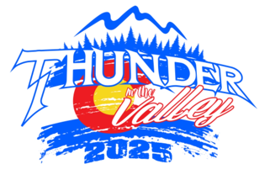
LEVELS OF SPONSORSHIP

Platinum
(Donation amount of $1000 or more in cash or in-kind gift)
- Sponsor will receive their name/business logo on our poster*, website and Facebook page.
- Sponsor name is announced as a “top” sponsor throughout the Thunder in the Valley event!
- Available Banner displayed around park, day of show (Banner provided by you)
- Company logo on T-shirt (Logo provided by you)
- Sponsorship packet and funds completed by March 15th.
- Top tier trophy, i.e. best paint. Let us know if you would like to present the trophy too!
- Your choice of one of the following:
  - Vendor booth on the day of the show (Valued at $50)
  - T-shirt from this year’s show (valued at $25)
  - 1 Car entry into the Car show on Saturday, July 11th (valued at $40)
Gold
(Donation amount of $500 to $999 in cash or in-kind gift)
- Sponsor will receive their name/business logo on our poster*, website and Facebook page.
- Sponsor name is announced as a sponsor throughout the Thunder in the Valley event!
- Your choice of one of the following:
  - Vendor booth on the day of the show (Valued at $50)
  - T-shirt from this year’s show (valued at $25)
  - 1 Car entry into the Car show on Saturday, July 11th (valued at $40)
Silver
(Donation amount of $150 to $499 in cash or in-kind gift)
- Sponsor will receive their name/business logo on our poster*, website and Facebook page.
- Sponsor name is announced as a sponsor throughout the Thunder in the Valley event!
- Your choice of one of the following:
  - T-shirt from this year’s show (valued at $25)
  - 1 Car entry into the Car show on Saturday, July 11th (valued at $40)
Trophy
(Donation amount of $50 to $149)

- Please let us know if you would like to present the trophy as well!

* Deadline to be on the poster is May 1st 2026!
Sponsor Contact Information
(Please print clearly)

Sponsor Name: ________________________________________________________
Business Name:________________________________________________________
Address: _____________________________________________________________
P.O. Box (If applicable): _________________________________________________
Phone Number: _______________________________________________________
Sponsorship Level: _____________________________________________________
Sponsorship Choice: (Mark one choice)
1) Vendor Booth ______ , 2) T-Shirt_______ Size ________, 3) Car Entry________
Cash/Check (including check #) or Gifts Donated :_____________________________ ______________________________________________________________________________________________________________________________________________________________________________________________________________________________________________________________________________________________________________________________________________________________________________________________________________________________
Thank you for your support and consideration in our event. We look forward to another successful year!

http://www.thunderinthevalleyshow.com/

