

**CLASSES:**

**Class 1: Pre 29**

**Class 2: 30 ~ 49**

**Class 3: 50 ~ 59**

**Class 4: 60 ~ 69**

**Class 5: 70 ~ 79**

**Class 6: 80 ~ 99**

**Class 7: 2000 ~ 2010**

**Class 8: 2011 ~ Present**

**Class 9: Rat Rod**

**Class 10: Truck**

**Class 11: Motorcycle**

**Class 12: Import**

**Class 13: Low Rider**

**\* Based on Pre-Registration, classes are subject to change\***

*Fountain, CO*

***CRUISE & CAR SHOW***

*July 7th & 8th 2023*

*Location:*

*Metcalfe Park (704 E. Ohio Ave, Fountain)*

*I understand by signing this invitation, I shall not hold the Thunder in the Valley directors responsible or liable for any mishap or accident arising from my attendance at the Show/Cruise. I also assume full responsibility for my guests that attend the Show/Cruise.*

Signature:___________________________________________________________________ Date:__________________________

Please make all checks payable to THUNDER IN THE VALLEY

**DEBIT OR CREDIT CARDS ARE NOT ACCEPTED PRIOR TO OR THE DAY OF THE SHOW!**

You may pre-register at the cruise for $35.00. The morning of the show, the registration fee will be $40.00. You can pay the registration fee the morning of the show at check-in or mail your entry form and check to P.O. Box 21 Fountain, CO 80817. For more information, please contact Sherri @ (719) 641-1710. All mailed in entries MUST BE POSTMARKED BY JULY 1st.

FIRST 50 ENTRIES RECEIVE A FREE T-SHIRT * FIRST 150 ENTRIES RECEIVE A FREE DASH PLAQUE

NAME:___________________________________________________________ PHONE:__________________________________

EMAIL ADDRESS:____________________________________________ SHIRT SIZE: S M L XL XXL XXXL (circle one)

ADDRESS:__________________________________________________________________________________________________

CITY:_______________________________________________________ STATE:_________________ ZIP:___________________

**Vehicle Info:**

Year:______________ MAKE:____________________________________ MODEL:______________________________________

*WOULD YOU LIKE TO PARTICIPATE IN THE THUNDER CHALLENGE? YES NO (circle one)*

PLESE CIRCLE WHICH CLASS YOU WOULD LIKE TO REGISTER FOR: (circle only one)

1 2 3 4 5 6 7 8 9 10 11 12 13

* Based on Pre-Registration, classes are subject to change*

~~~~~~~~~~~~~~~~~~~~~~~~~~~~~~~~~~~~~~~~~~~~~~~~~~~~~~~~~~~~~~~~~~~~~~~~~~~~~~~~~~~~~~~~~~~~~~~~~~~~~~~~~~~~

For more information:

visit our website @ [www.thunderinthevalleyshow.com](http://www.thunderinthevalley.com) or visit Facebook [www.facebook.com/ThunderInTheValleyCarShow.com](http://www.facebook.com/ThunderInTheValleyCarShow.com)

**\*AWARDS * PRIZES * FOOD * MUSIC * THE THUNDER CONTEST * *FUN FOR THE WHOLE FAMILY\***

***SATURDAY CAR SHOW***

*July 8th 2023*

*Gates open at 7:00am*

*Show is from 9:00am to 2:00pm*

***FRIDAY NIGHT CRUISE***

*July 7th 2023*

*4:00pm - Show & Shine 4:30pm - Cruise*

*\*Pre-Register for the Car Show at the Cruise\**

*CAR SHOW*

**ALL YEARS / MAKES / MODELS**

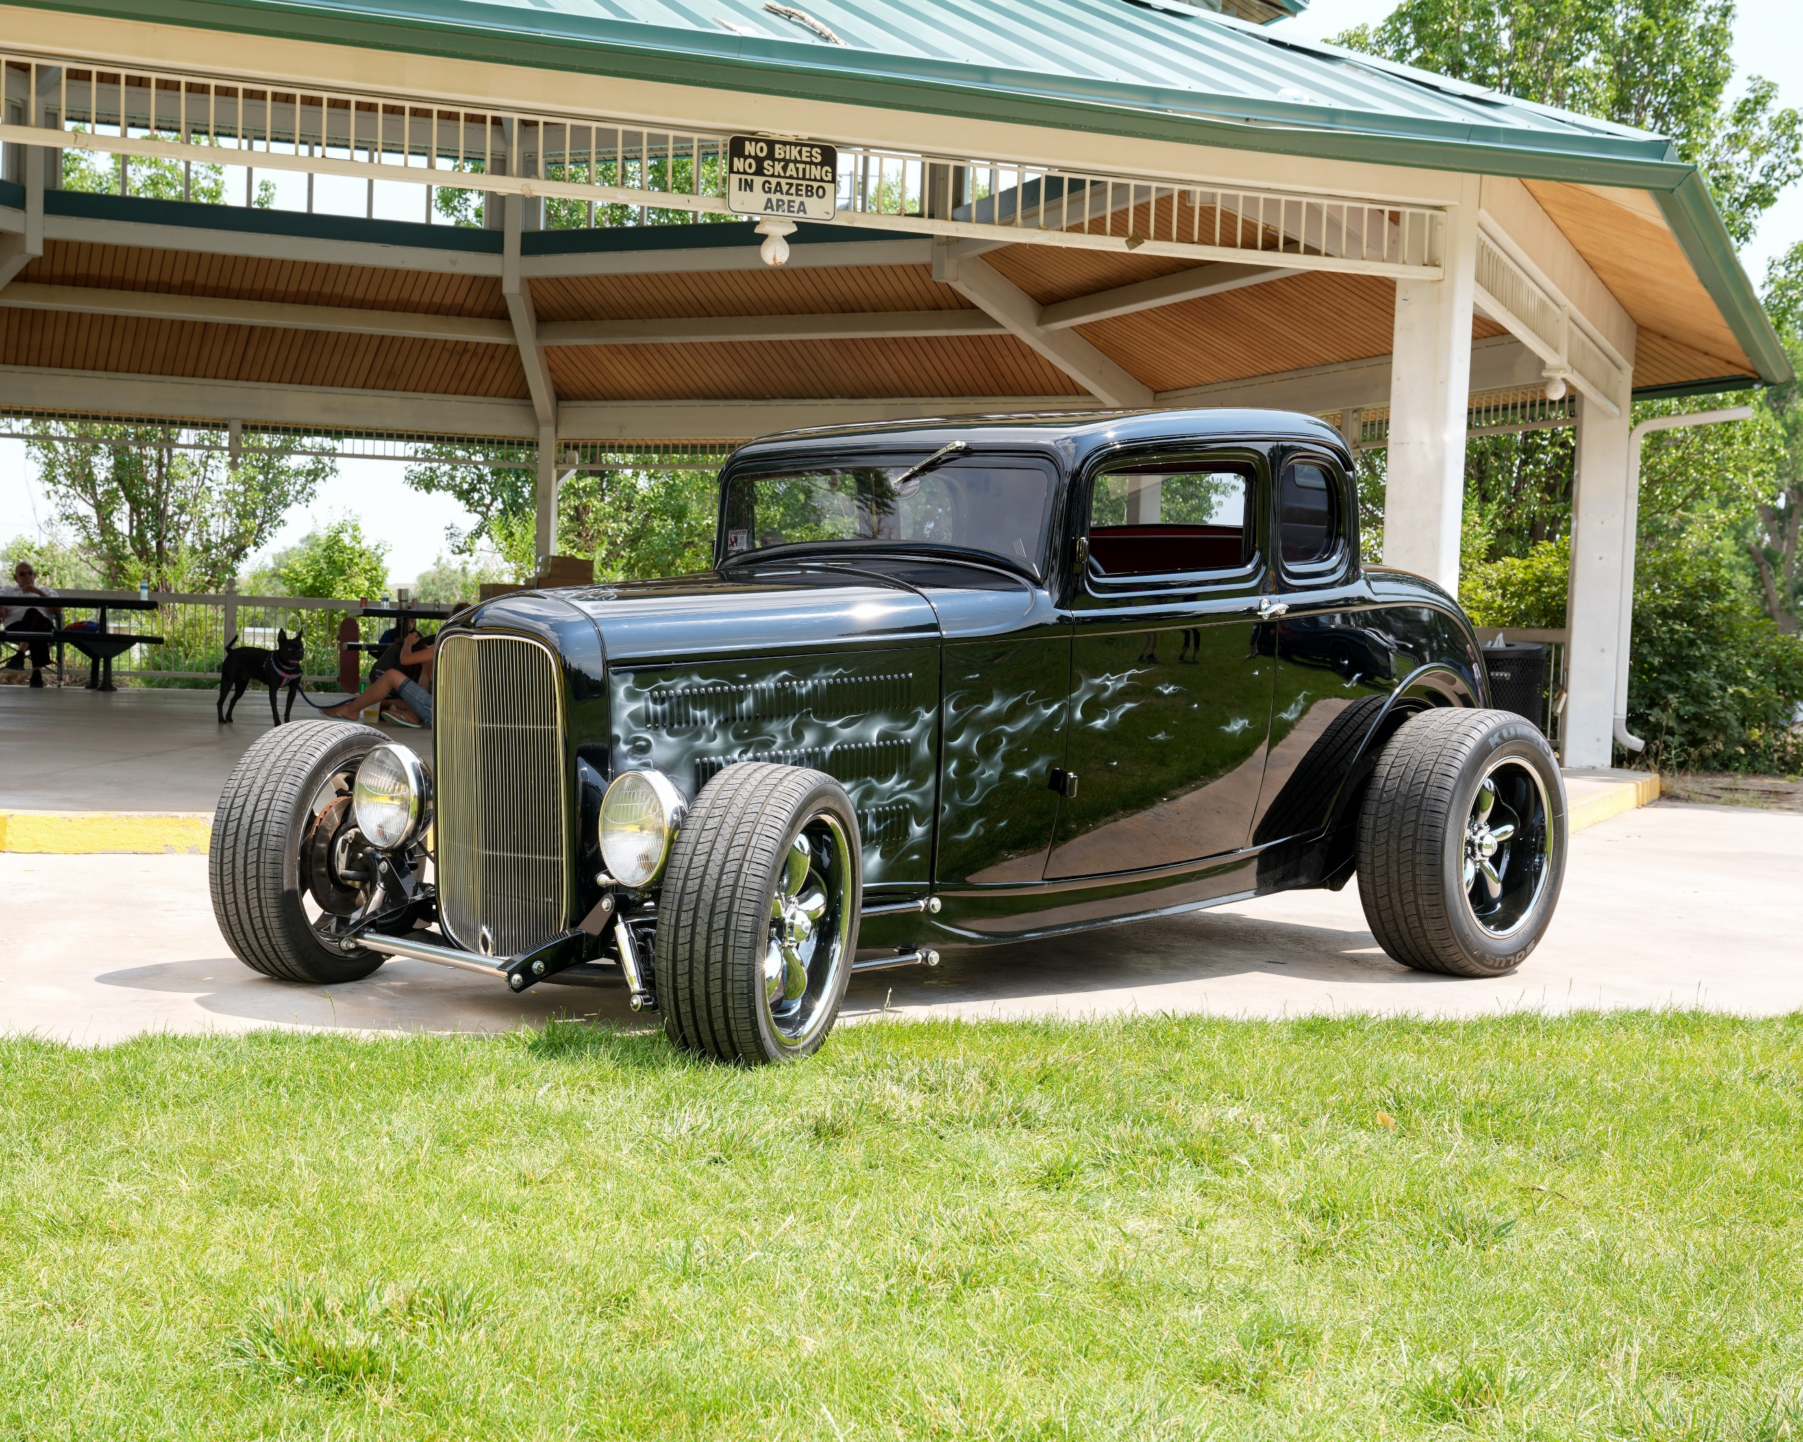

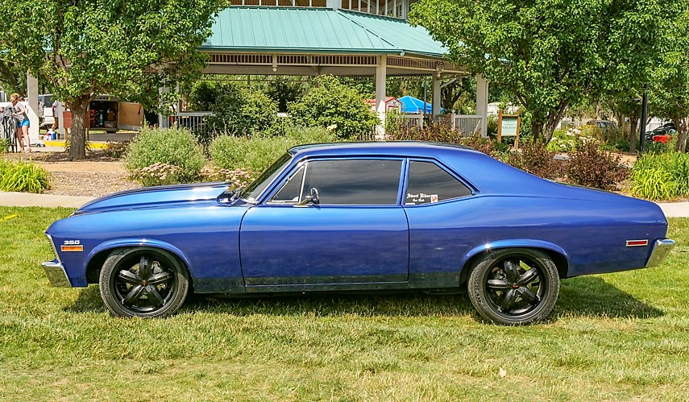

*Fountain, CO*



***CRUISE & CAR SHOW***

*July 7th & 8th 2023*

*Location:*

*Metcalfe Park (704 E. Ohio Ave, Fountain)*